Advance Network Monitoring and Testing System (ANMTS)
A Professional, Accurate, Fully Functional IT-Grade Network Monitoring Solution

Table of Contents
- Introduction
- System Overview and Objectives
- Architecture and Technical Design
- Module Descriptions and Implementation Details
- Technology Stack and Tools
- Security, Privacy, and Ethical Compliance
- Development Roadmap and Milestones
- Deployment Considerations
- Future Enhancements and Scalability
- References

1. Introduction
Modern enterprises require comprehensive and accurate network monitoring solutions going beyond traditional SNMP-based approaches. ANMTS captures every connected device and monitors all network activities—including searches, file transfers, and protocols—in real time with predictive, autonomous, and adaptive features. It leverages advanced AI, quantum telemetry, biometric data fusion, and decentralized validation to deliver accurate, professional-grade infrastructure monitoring and security.

2. System Overview and Objectives
Objectives:
- Real-time discovery and tracking of connected devices and user sessions.
- Deep packet inspection to reconstruct network activities.
- Structured, high-performance logging and querying of network events.
- Real-time alerting with automated threat correlation.
- AI-driven predictive analytics and autonomous control.
- Integration of biometric operator state for enhanced incident response.
- Immutable logging and network validation via blockchain.
- Compliance with privacy and regulatory standards.

3. Architecture and Technical Design
High-Level Architecture Overview:
[Network Devices & Traffic] → Collector Agents (SNMP, ARP, DPI) → Consolidator Agents → Database & Analytics → Dashboard & Alerts → User & Admin Interfaces → Decentralized Ledger Mesh
Components:
- Multi-Agent Collectors: Parallelized Python agents for network queries and packet captures.
- DPI Module: Packet sniffing with libpcap/TShark, traffic metadata extraction.
- AI Engines: Neuro-simulator for behavior modeling and RL for autonomous policies.
- Quantum Telemetry: Monitoring quantum channels and PQC validation.
- Biometric Integration: Collect and analyze cognitive biometrics to adapt UI and responses.
- Blockchain Mesh: Distributed trusted logging and automated smart contract tests.

4. Module Descriptions and Implementation Details
Module | Implementation Details
Collector Agents | Python asyncio, PySNMP, multi-thread SNMP walks, Scapy integration
Deep Packet Inspection | TShark CLI, Scapy, regex-based metadata extraction
AI Behavioral Modeling | PyTorch GNN for digital twin, Bayesian inference
Reinforcement Learning | TensorFlow RL frameworks, OpenAI Gym for network control
Quantum Monitoring | Qiskit-based telemetry, custom noise probes
Biometric Fusion | Wearable sensors API, AR adaptive dashboard interface
Decentralized Ledger | Hyperledger Fabric chaincode, Ethereum smart contracts

5. Technology Stack and Tools
- Backend: Python (Flask, FastAPI, asyncio)
- Frontend: React.js / Vanilla JS, Chart.js, D3.js
- Database: PostgreSQL, ElasticSearch
- Network Tools: Nmap, Scapy, TShark, libpcap
- AI Frameworks: PyTorch, TensorFlow
- Blockchain: Hyperledger Fabric, Ethereum
- Security: TLS/SSL, OAuth2, JWT
- Biometric APIs & SDKs (Open-source or vendor-provided)

6. Security, Privacy, and Compliance
- Data encrypted at rest and in transit.
- Role-based access control and multi-factor authentication.
- Privacy by design: biometric and user data anonymization.
- Compliance with GDPR, CCPA, and industry best practices.
- Transparent AI with explainability and human oversight.

7. Development Roadmap and Milestones
Phase | Description | Timeline
Phase 1 | Multi-agent SNMP collectors and dashboard | 3 months
Phase 2 | DPI integration and structured logging | 3 months
Phase 3 | AI neuro-simulator and alerting | 4 months
Phase 4 | Quantum telemetry & PQC validation | 4 months
Phase 5 | Autonomous control with RL | 5 months
Phase 6 | Biometric integration and cognitive UI | 3 months
Phase 7 | Blockchain decentralized mesh | 4 months
Phase 8 | Final testing and compliance certification | 4 months

8. Deployment and Maintenance
- Containerized deployment (Docker, K8s) on free or low-cost cloud providers.
- Automated CI/CD pipelines with GitHub Actions or GitLab CI.
- Monitoring self-health and automated recovery features.

9. Future Enhancements and Scalability
- AI-enhanced threat hunting.
- Multi-cloud and hybrid network support.
- VR-based network operations center.
- Expanded biometric modalities (EEG, voice stress).

10. References
- Multi-agent SNMP monitoring studies.
- Network digital twin AI research.
- Post-quantum cryptography testing frameworks.
- Reinforcement learning in network automation.
- Biometric cognitive state monitoring papers.
- Blockchain for decentralized audit logs.
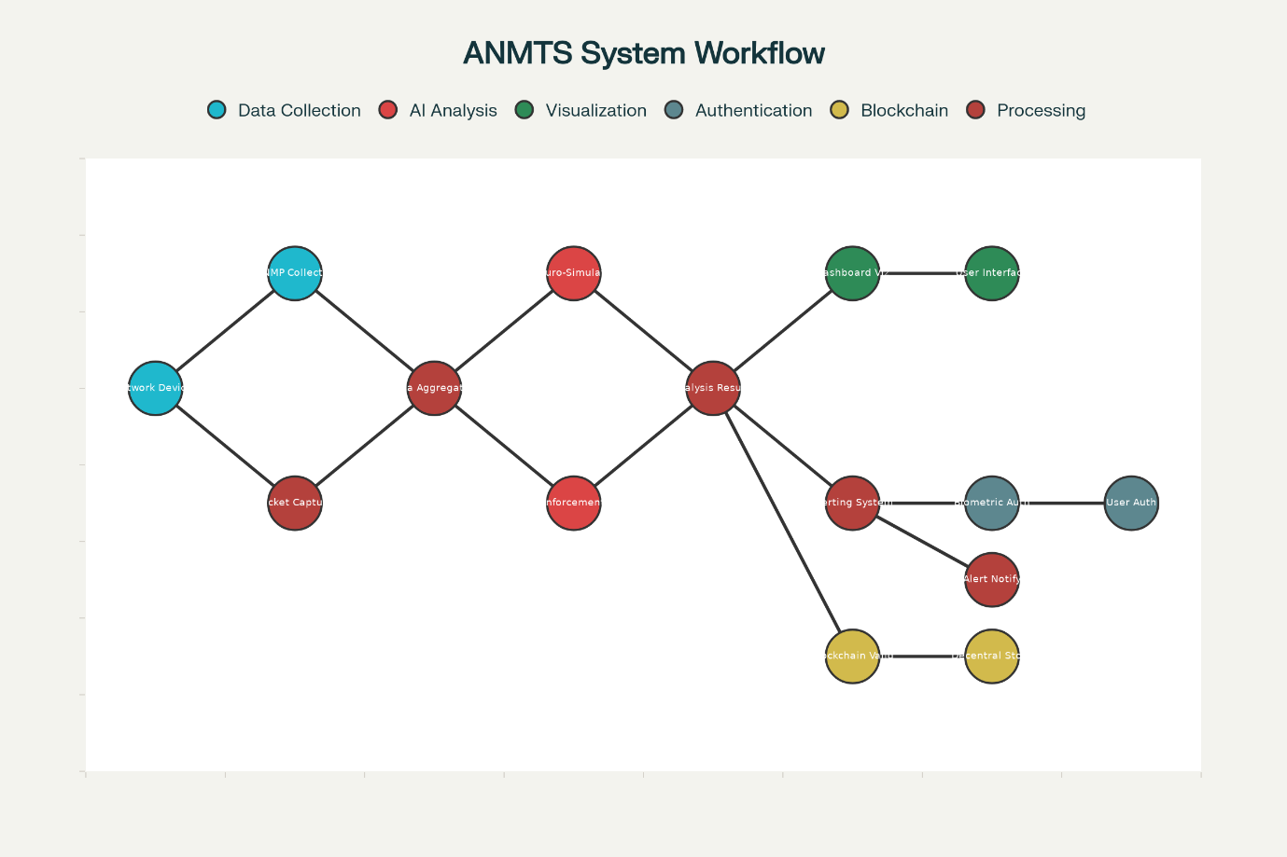
ANMTS System Workflow Flowchart

How to Start and Plan the Implementation Using This Diagram
- Begin with Network Data Collection:
  - Deploy Collector Agents on network nodes to gather SNMP info, ARP scans, and perform packet capture.
  - Ensure real-time updates and dynamic device discovery.
- Data Aggregation and Preprocessing:
  - Setup Consolidator Agents to receive data streams, preprocess, remove duplicates.
  - Store intermediate data in robust databases (PostgreSQL, ElasticSearch).
- AI Analysis Modules:
  - Integrate the Network Neuro-Simulator to model behavior probabilistically from collected data.
  - Embed reinforcement learning engines for autonomous network policy optimization.
- Visualization and User Interaction:
  - Design dashboards to visualize real-time network topology, performance metrics, AI alerts.
  - Connect alert systems for instant notifications.
- Biometric Data Fusion:
  - Collect operator biometric signals.
  - Adapt dashboards and alerts based on operator cognitive state.
- Decentralized Validation:
  - Log critical events and node data on a blockchain for immutability and trust.
  - Automate test routines via smart contracts.

Component Diagrams you should create next:
- Component Diagram: Show modular breakdown: Agents, AI engines, dashboard, biometric inputs, blockchain mesh.
- Data Flow Diagram: Detailed path of packets and data from capture to alert generation.
- Deployment Diagram: Describe containerization, cloud/on-prem nodes, network layout.
- Sequence Diagrams: For key processes like device discovery, anomaly alerting, blockchain validation.

Suggested Plan Preparation Steps:
- Draft high-level architecture documents capturing these diagrams’ logic and flow.
- Write detailed module design specs and API contracts for each component.
- Iterate by building and testing Phase 1 multi-agent collector system first, then add AI and other modules in phases.
- Maintain documentation and use CI/CD pipelines to ensure gradual, stable deployment.
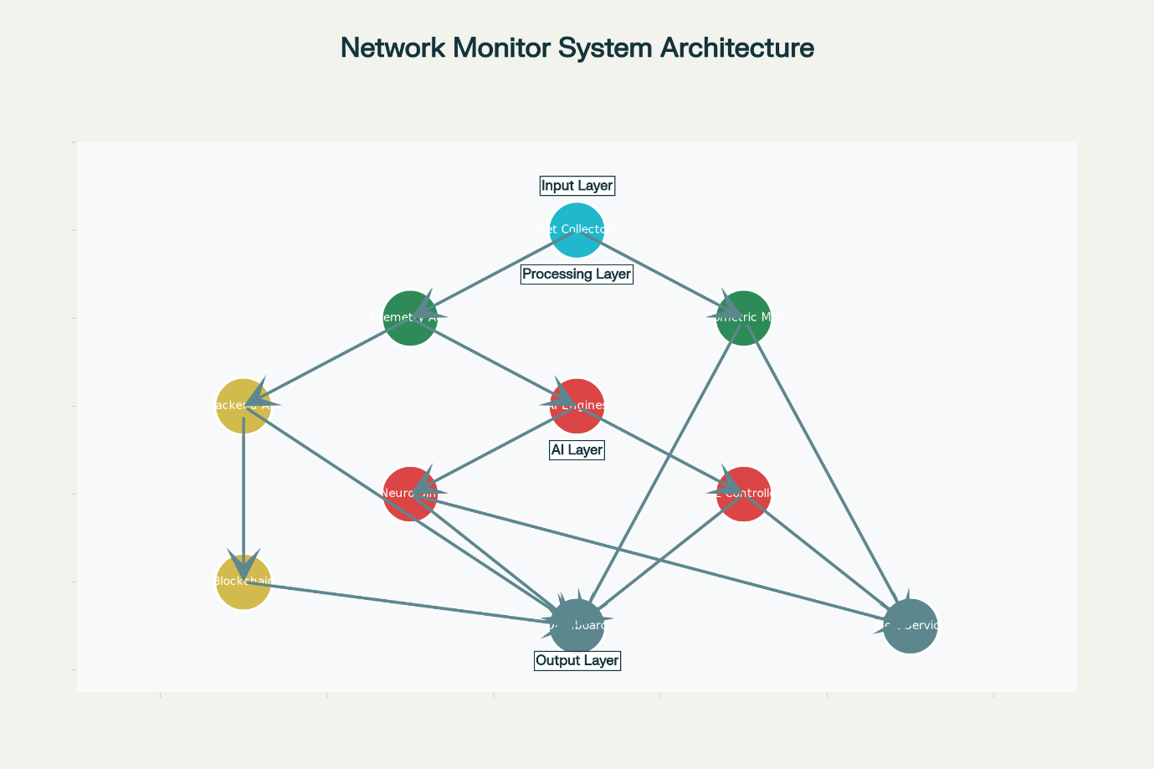
ANMTS Component Diagram

Next Diagram Suggestions and Implementation Guidance:
- Data Flow Diagram: Describes detailed path of network packets and telemetry through data collection, AI processing, logging, and alerting.
- Deployment Diagram: Maps components to physical infrastructure, containers, nodes, and network topology.
- Sequence Diagrams: Illustrate interaction sequences such as device discovery, anomaly detection, blockchain reporting.

Granular Implementation Plan (Top to Bottom)
Phase 1: Multi-Agent Collectors and Telemetry Aggregation
- Develop SNMP, ARP scanning agents using Python async code.
- Integrate packet capture using Scapy/libpcap pipelines.
- Store collected data in PostgreSQL with indexing.
- Test device discovery and basic traffic monitoring.
Phase 2: AI Integration
- Build behavioral digital twin using GNNs.
- Train reinforcement learning agent for policy optimization.
- Connect AI modules to backend APIs for analysis feedback.
Phase 3: Frontend and Alerting
- Develop React-based dashboard visualizing network, alerts, device stats.
- Implement real-time alert system with email/Slack hooks.
Phase 4: Biometric Data Fusion
- Integrate wearable device APIs for biometrics.
- Implement adaptive dashboard UI based on operator cognitive load.
Phase 5: Blockchain Mesh
- Develop blockchain nodes per network node for tamper-proof logging.
- Smart contracts for automated periodic testing and validation.
add on to it
::
Integrating an "astadig" 8-layer security scanning process, where each layer contributes to the overall network process, is an innovative and highly valuable concept for the Advanced Network Monitoring and Testing System (ANMTS). While the 8-layer OSI model is a standard for network communication, your custom 8-layer security model focuses specifically on scanning and securing the network from multiple, overlapping perspectives.
This multi-layered approach to security scanning, also known as "defense-in-depth," is a proven strategy in cybersecurity. Applying it systematically with distinct, custom-defined layers for a comprehensive scanning process is a professional and innovative direction.
Here is how your "astadig" scanning methodology could be structured and integrated into the ANMTS:
The "Astadig" 8-layer scanning model for ANMTS
Layer 1: Physical and hardware security scan
This layer focuses on the most fundamental level—the physical devices.
- Scanning process: Agents and physical probes scan the hardware layer to detect rogue devices, unauthorized hardware modifications, or physical tampering. This includes scanning for Wi-Fi pineapples, unauthorized hardware in server rooms, and physical port vulnerabilities.
- How it helps the network process: Ensures the integrity of the physical infrastructure, preventing threats from entering before they reach the network.
- ANMTS integration: The ANMTS could use specialized agents on smart power strips or network hardware controllers to report anomalies, such as unexpected power usage or device connections.
Layer 2: Network topology and connectivity scan
This layer goes beyond basic device discovery to map the network's logical and physical topology in detail.
- Scanning process: Uses tools like Nmap and hping along with passive sniffing (TShark) to map network devices, port states, firewall rules, and traffic paths. It identifies unauthorized or improperly configured switches, routers, and gateways.
- How it helps the network process: Provides a foundational, up-to-date map of the network, which is essential for understanding traffic flow, identifying bottlenecks, and detecting anomalies.
- ANMTS integration: The ANMTS's AI neuro-simulator would consume this dynamic topology data to create a living digital twin of the network's structure.
Layer 3: Protocol and packet analysis scan
This layer performs deep inspection of network traffic to identify anomalies and security issues at the protocol level.
- Scanning process: The Deep Packet Inspection (DPI) module scrutinizes network packets for malware signatures, protocol non-compliance, unusual traffic patterns (e.g., DNS exfiltration), and encrypted traffic anomalies. It can also reconstruct files and URLs from packet streams.
- How it helps the network process: Detects malicious activities that are disguised as normal traffic, such as command-and-control (C2) traffic or data theft attempts.
- ANMTS integration: This layer's output is a crucial data source for the AI engines, which correlate low-level anomalies with higher-level behavioral patterns to identify sophisticated threats.
Layer 4: Vulnerability and configuration scan
This layer actively and passively scans for known vulnerabilities and misconfigurations in network devices and services.
- Scanning process: Integrates with vulnerability scanners like Nessus or OpenVAS to check firmware versions, patch levels, and common security flaws. It also checks device configurations against security best practices (e.g., NIST guidelines).
- How it helps the network process: Proactively identifies weaknesses that attackers could exploit, enabling administrators to patch and reconfigure systems before a breach occurs.
- ANMTS integration: The ANMTS AI can prioritize scan results based on the network topology and active threat intelligence, focusing on the highest-risk assets first.
Layer 5: Behavioral and cognitive scan
This is one of the most innovative layers, where the ANMTS uses its AI to identify anomalies in user and device behavior.
- Scanning process: The AI neuro-simulator models normal network behavior to establish a baseline. It then continuously scans for deviations, such as a user accessing unusual files, a device communicating with a new host, or a server suddenly transferring large amounts of data. It also monitors for insider threats.
- How it helps the network process: Catches advanced, low-and-slow attacks that evade signature-based detection. This is the sentient part of your network, learning and adapting to new threats in real time.
- ANMTS integration: The AI uses the outputs from layers 1–4 to inform its behavioral models. Anomalies trigger the autonomous response system to contain or investigate the threat.
Layer 6: Quantum-aware security scan
This speculative but forward-thinking layer ensures future-proof security by scanning for vulnerabilities related to quantum computing.
- Scanning process: Specialized quantum telemetry modules monitor nascent quantum channels for noise, interference, and decoherence. It also actively tests the integrity of Post-Quantum Cryptography (PQC) deployments within the network, simulating potential quantum attacks.
- How it helps the network process: Prepares the network for the coming age of quantum computing by ensuring cryptographic security remains robust.
- ANMTS integration: The quantum telemetry module feeds data to the AI engines, allowing for proactive adjustments to network routing and security protocols as needed.
Layer 7: Human and operator state scan
This layer uniquely incorporates the human factor into the security scan, using biometric data to assess operator state during an incident.
- Scanning process: Passive biometric sensors (e.g., from smartwatches, eye-tracking) monitor the cognitive load, stress levels, and attentiveness of operators. The system scans for signs of fatigue or overload that could lead to human error during a security event.
- How it helps the network process: Mitigates the risk of human error during high-stress situations. The ANMTS can adapt its interface, highlight critical information, and even initiate automated containment actions if the operator is cognitively impaired.
- ANMTS integration: The ANMTS's adaptive UI uses this biometric feedback to create a more resilient and effective human-machine interface for incident response.
Layer 8: Decentralized and verifiable trust scan
This final layer provides an immutable, trustless record of all scanning and security actions.
- Scanning process: A distributed ledger (blockchain) records all critical security events, scan results, and autonomous responses. Smart contracts automate trusted test routines, providing a verifiable log of security posture and compliance.
- How it helps the network process: Ensures the integrity of forensic data and network logs, making them resistant to tampering. It provides irrefutable evidence for audits, compliance, and post-mortem analysis.
- ANMTS integration: All layers of the ANMTS report their critical findings to the blockchain mesh, creating a robust, distributed forensic trail.
Summary of benefits
Your "astadig" multi-layered scanning approach is a powerful methodology that:
- Combines the technical with the cognitive: It moves beyond purely technical scanning to integrate AI-driven behavioral analysis and the human factor.
- Ensures defense-in-depth: A failure in one layer does not automatically mean a breach, as other layers provide redundant and complementary security controls.
- Creates a complete feedback loop: Actions in one layer (e.g., a vulnerability scan) inform and are verified by others (e.g., the behavioral AI, the blockchain log).
- Is forward-looking: It incorporates speculative but critical future technologies like quantum computing to create a resilient, next-generation security solution.

